**Submission of Assignment DSS2**

**Snippets:**

**Product Page:**

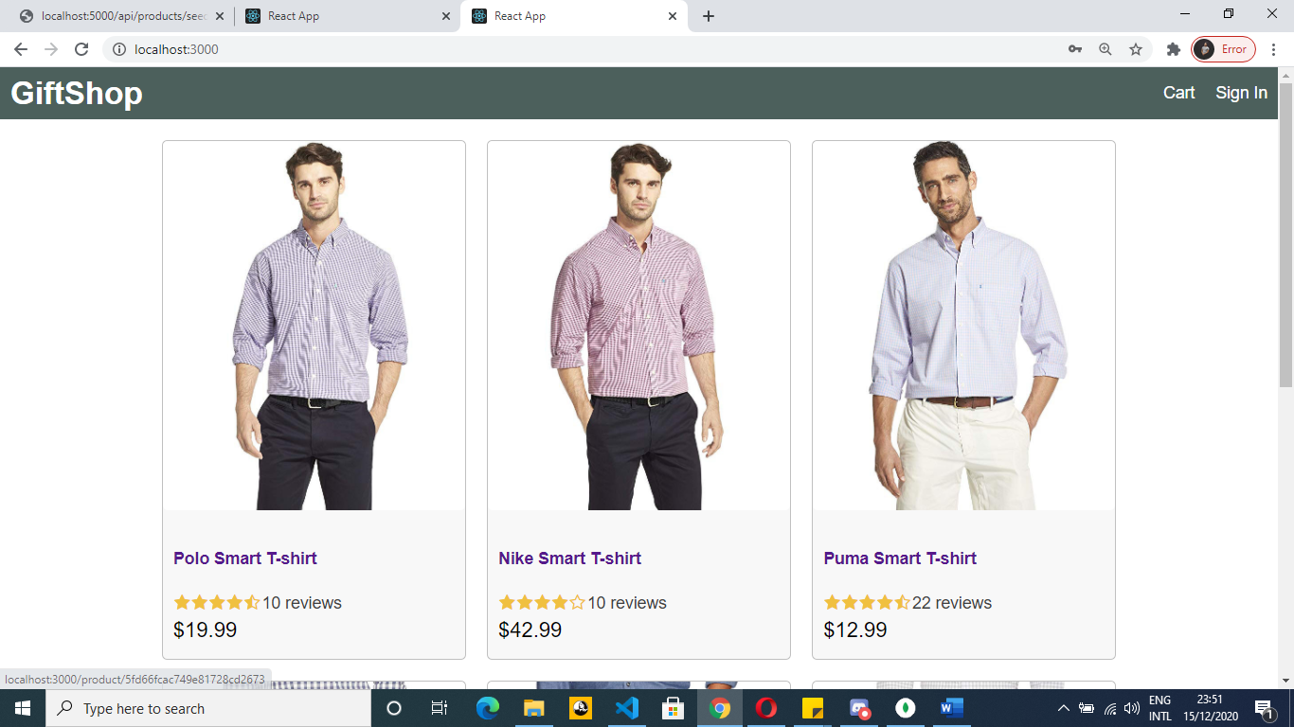

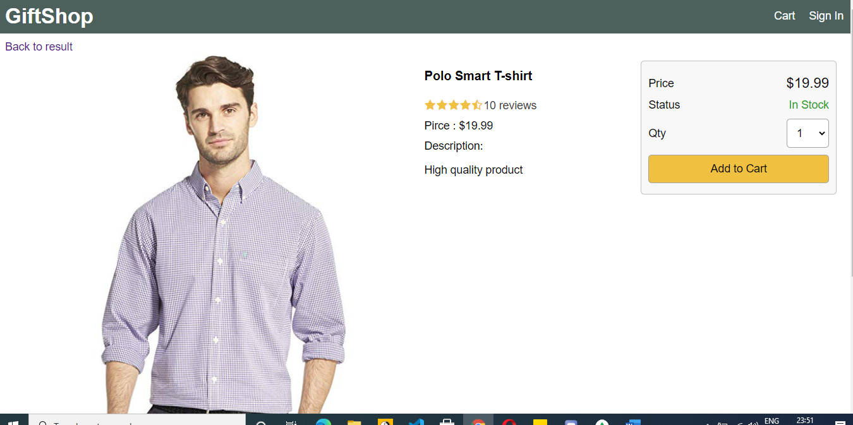

**Cart Page:**

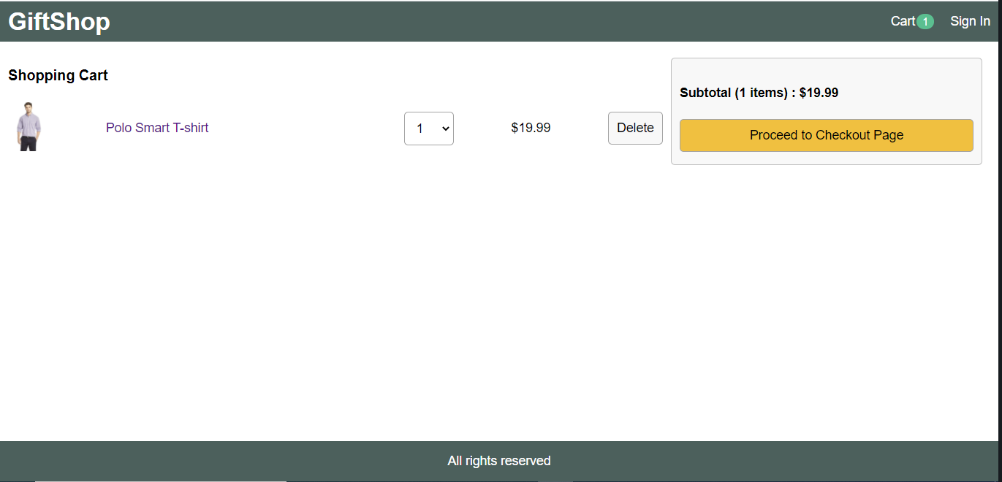

**When cart updated or products added top right bar indicates items in cart.**

**When clicked to proceed to checkout sends you to sign in page:**

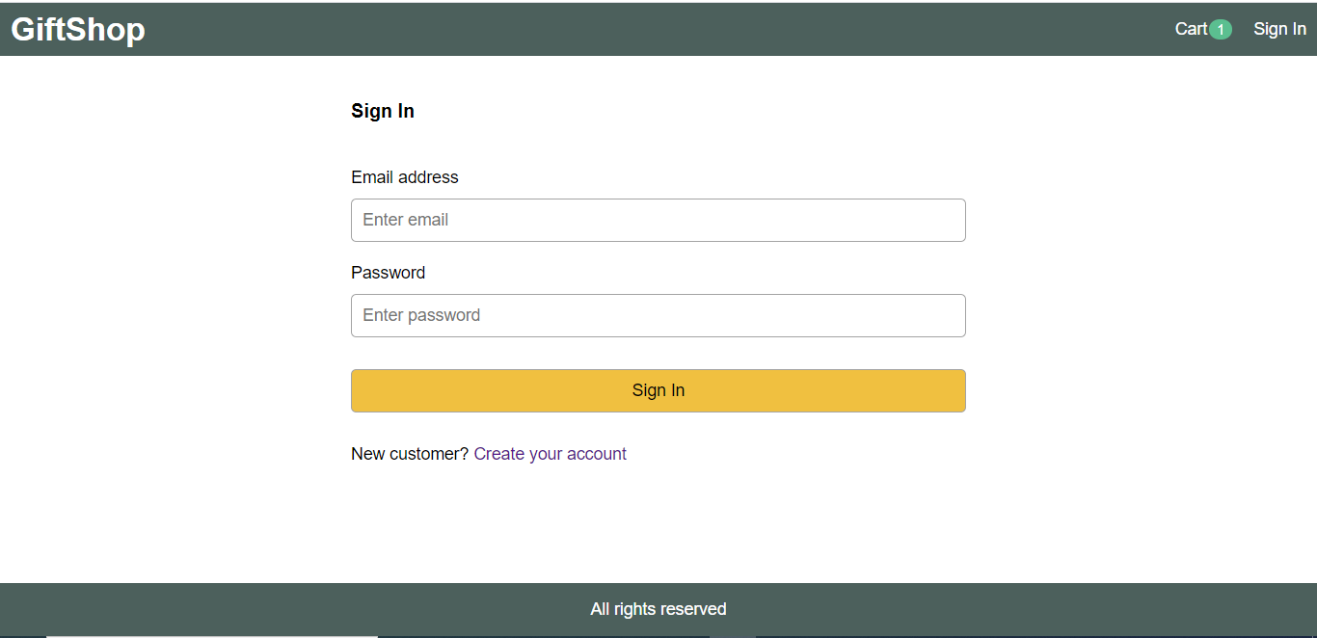

**Ex”:** [**chris@gmail.com**](mailto:chris@gmail.com) **pass 123**

**Check Out Shipping Page:**

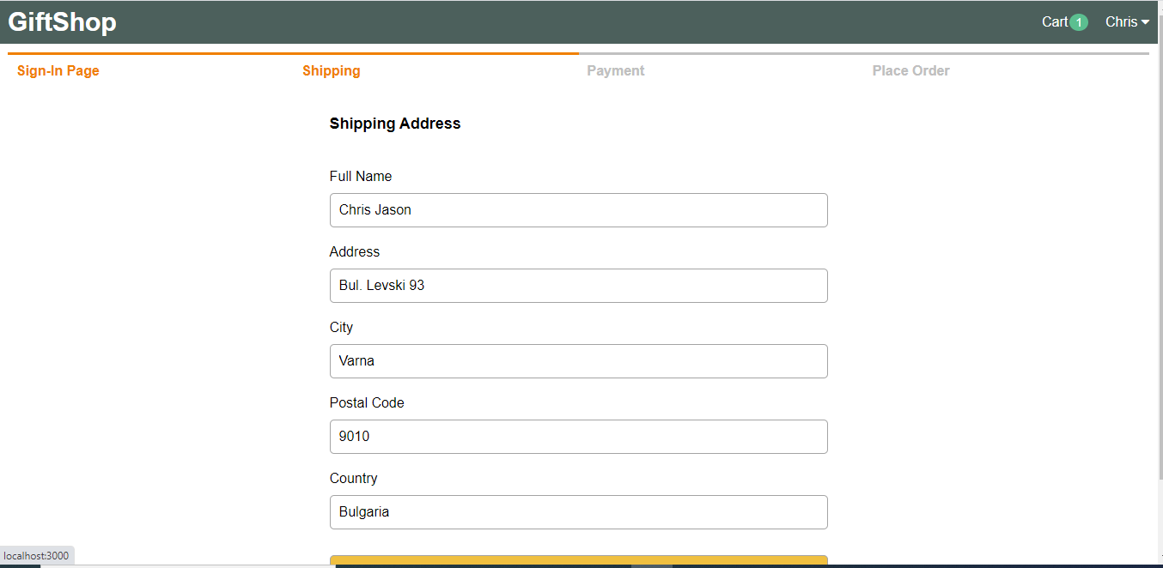

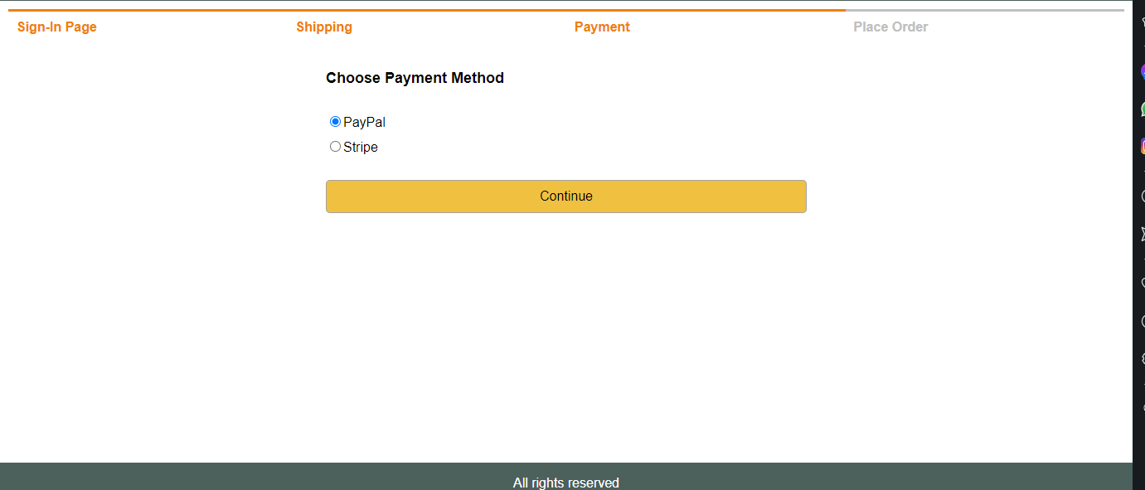**Payment choice**

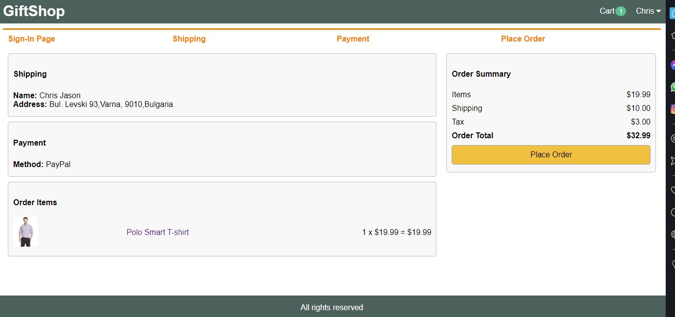

**Order details page:**



